G63

GSOE 9820
IT



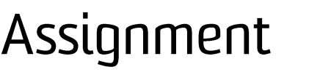


- Please print clearly and complete all sections. All group members must sign the declaration below.
- Before submitting this assignment, students are strongly recommended to review the course outline, assessment requirements, UNSW’s Plagarism and Academic Integrity website and Administrative Matters on the School’s website.
- Please retain a copy of this assignment for your records.

Course code: GSOE 9820 Course name: Project Management, Term 1 2026

Date submitted:

In preparing this assessment task we have followed the Student Code Policy. We certify that we have read and understand the University requirements in respect of student academic misconduct outlined in the StudentCode Policy and the Student Misconduct Procedure. We declare that this assessment item is our own work, except where acknowledged, and has not been submitted for academic credit previously in whole or in part.

We acknowledge that the assessor of this item may, for assessment purposes:

- Provide a copy to another staff member of the University
- Communicate a copy of this assessment item to a plagiarism checking service which may then retain a copy of the assessment item on its database for the purpose of future plagiarism checking.

We have retained a copy of this, our assignment, which we can provide if necessary. By signing this declaration we are agreeing to the statements and conditions above.

- Team Attribution Survey and Signature Table

FAMILY NAME | GIVEN NAME(S) | STUDENT ID | CONTRIBUTION (%) | SIGNATURE
LI | CHENZI | z5615327 | 16.67 | 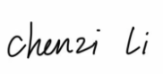
MENG | JACK | z5528351 | 16.67 | 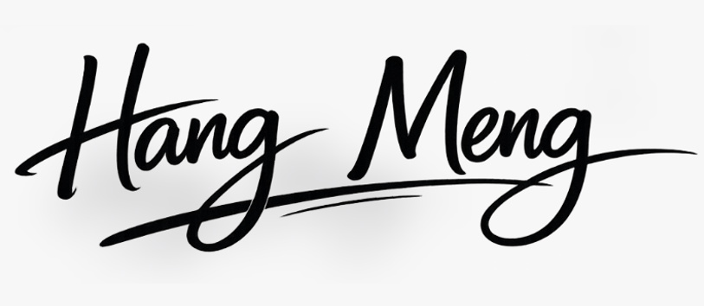
YANG | XINGYU | z5429763 | 16.67 | 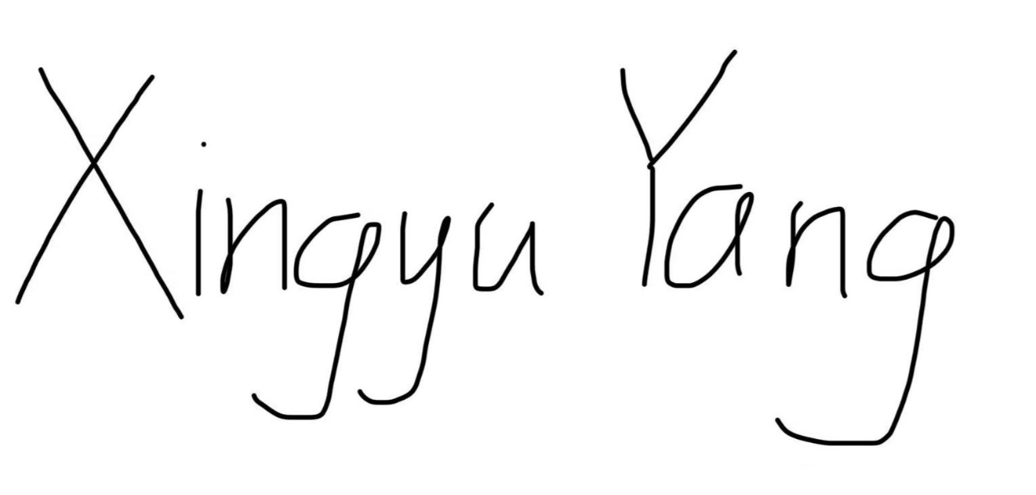
HAN | PEIXIN | z5657410 | 16.67 | 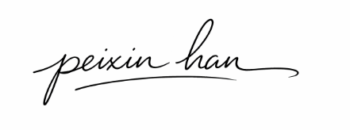
SUN | ZHENGYUAN | z5572114 | 16.67 | 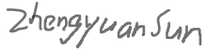
MU | ETHAN | z5519838 | 16.67 | 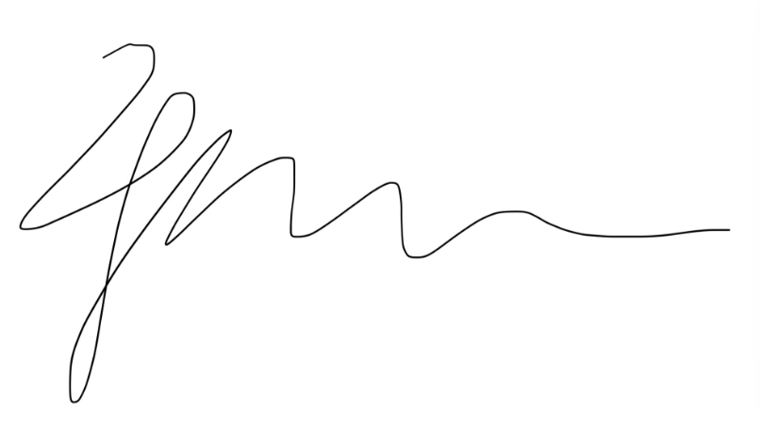

Grading procedure:

- The report is marked according to the marking guide giving raw grade R.
- The team’s demonstrator will check, modify if necessary, and approve the team attribution survey.
- The approved contribution of a group member is C.
- Each group member receives a final grade F = R x C x N (where N is number of group members).
- You will be individually notified of F and R.

Table of Contents
1. Team Attribution Survey and Signature Table 1
1. Project Charter 1
1.1 Purpose Statement 1
1.2 Objectives and Success Criteria 1
1.3 Requirements 2
1.4 Project Boundaries 2
1.5 Stakeholder List 3
1.6 Summary of Schedule and Milestones 4
1.7 Summary of Preliminary Budget 5
1.8 High Level Risks 6
1.9 Definition of Success 7
1.10 PMBOK Referenced PM Methods Used in Project Charter Aim - Discussion 7
2. Scope Management 8
2.1 Scope Statement 8
2.2 Deliverables 8
2.3 Constrains 8
2.4 Exclusions 9
2.5 WBS 10
3. Stakeholder Management 11
3.1 Stakeholder Identification 11
3.2 Stakeholder Engagement Plan 12
3.3 Stakeholder Engagement Management 13
3.4 Stakeholder Engagement Monitoring 15
4. Schedule Management 16
4.1 Discussion 16
4.2 Activity List 19
4.3 Milestone Timeline 21
4.4 Network Diagram 21
4.5 Gantt Chat 23
5. Budget Management 25
5.1 Overview of Budget 25
5.2 Integrated Project Budget 27
5.2.1 Time-Phased Budget 28
5.2.2 Cost Estimation Table 30
5.2.3 Contingency Reserve 31
5.3 Cost Estimates Basis 31
5.4 PMBOK Referenced PM Methods 31
6. Risk Management 32
6.1 Overview of Risk Management 32
6.2 Risk Identification 33
6.3 Risk Assessment 34
6.4 Risk register 35
7. Communications Management Plan 37
7.1 Overview 38
7.2 Plan Resource Management 38
7.2.1 Communication Requirement Analysis 39
7.2.2 Communication Technology and Tools 40
7.2.3 Communication Methods 41
7.2.4 Project Information System Table 42
7.3 Manage Communications 46
7.4 Monitor Communications 46
7.4.1 Collecting Feedback 46
7.4.2 Adjusting Communications 47
7.5 PMBOK Referenced PM Methods Used in Communications – Discussion 47
8. Quality management plan 48
8.1 Purpose of Quality Management 48
8.2 Quality Objectives and Standards 48
8.3 Quality Assurance Methods 49
8.4 Quality Control Methods 50
8.5 Quality Monitoring and Reporting 52
8.6 Quality Monitoring and Reporting 53
8.7 Corrective Actions and Change Control 54
8.8 PMBOK Referenced PM Methods Used in Quality Management – Discussion 54
Appendix 1
1. Risk Register table 1
2. Reference 4

Project Charter

Purpose Statement
The purpose of this project is to plan and manage the delivery of the UNSW AI-Powered Research & Academic Equity Companion, a university-focused AI project with the aim of helping students from underrepresented groups succeed in research-based learning and academic progression. This project is intended to be a planning and management project rather than a technical project and aims to deliver a complete and integrated Project Management Plan (PMP) document to guide the project execution in the future. This project has a project duration of 12 months, spanning March 2026 to February 2027, and a project budget constraint of AUD 350,000.
This project charter outlines the project’s purpose and scope statement, project objectives and requirements, project boundaries and scope statement, project stakeholders and scope statement, project schedule and budget summary, project risks, and definition of project success. This project charter is intended to serve as a common basis upon which the rest of the project’s Project Management Plan (PMP) can be developed in a consistent manner.

Objectives and Success Criteria
The main goal of this project is to develop an appropriate, realistic, and professionally developed Project Management Plan for the UNSW AI-Powered Research & Academic Equity Companion. This project management plan must provide an appropriate definition of the project, which will enable any future project team to use the completed planning package to lead to project implementation. The specific objectives of this project are to develop an appropriate project scope statement, identify major stakeholders and their needs, develop an appropriate project schedule, develop an appropriate preliminary and traceable project budget, document the communication plans, address the major risks, and develop validation and pilot planning outputs.
This project will be considered successful if the developed project charter and management plans are internally consistent, align with the project brief, are supported with appropriate references to PMBOK methodologies, and are realistic within the established time and budget constraints. Success will also depend on the clarity, integration, and appropriateness of the final project planning outputs.

Requirements
At a higher level, what is needed is a complete planning and management package for the UNSW AI-Powered Research & Academic Equity Companion. The Work Breakdown Structure (WBS) has identified seven major work packages in this project, namely Project Governance & Baselines, Requirements & User Analysis Pack, Solution Architecture & Integration Design Pack, Core Capability Design Pack, Compliance, Privacy, and Accessibility Pack, Validation and Pilot Evaluation Pack, and Final Documentation Set. These are the major planning and management outputs needed for this project.
In addition, what are also needed in this project are the following specific deliverables under these work packages, namely Project Charter, governance and stakeholder management plan, schedule baseline, budget baseline, risk, issue, and assumption register, quality and acceptance criteria pack, requirements specifications, design outputs, compliance documentation, validation approaches, and final project report and recommendations.

Project Boundaries
The limits and boundaries of this particular project have been defined and documented in the scope document. The various activities that will be carried out in this particular project include planning, stakeholder management, requirements development, system design planning, governance planning, communication planning, risk planning, validation planning, and finally, documentation. The major deliverables will be the Project Charter, Work Breakdown Structure, Scope Baseline, Stakeholder Management Plan, Schedule Baseline, Budget Baseline, Communication Plan, Risk Register, and finally, the Project Management Plan.
The activities that will be excluded in this particular project will be the deployment of the entire AI platform, real integration with UNSW production systems, detailed software coding, production testing, and finally, operational support. These activities will be excluded from the project in order to ensure that the project remains achievable within the 12-month timeframe and a budget of AUD 350,000.
This charter, therefore, defines a particular project that will be a structured project management and planning activity, preparing for future implementation rather than developing a fully operational system within this particular project.

Stakeholder List
The project involves a range of internal and external stakeholders with different interests, influence levels, and information needs. Based on the stakeholder and communications planning documents, the main stakeholders include:
Stakeholder | Role / Interest in Project
Project Sponsor / UNSW Senior Leadership | Provides strategic direction, approves key decisions, and monitors milestones, risk, budget, and alignment
Project Manager / Core Project Team | Responsible for project coordination, planning integration, progress control, and delivery of major outputs
Technical Lead, Developers, and QA Team | Support technical planning, architecture, testing, integration, and compliance-related design considerations
Academic Advisors / Supervisors | Review educational fit, academic workflow support, and academic integrity considerations
Equity Students / Pilot Users | Represent end-user needs and provide feedback on accessibility, usability, clarity, and support needs
UNSW Library / IT Services | Review integration readiness, operational concerns, privacy controls, and compliance evidence
Equity and Diversity Office | Interested in inclusive design, student outcomes, and strategic alignment with widening participation goals
Compliance / Privacy / Security Stakeholders | Ensure the project aligns with institutional governance, privacy, and legal expectations
This is important because the success of the project depends on the quality of the plans as well as the level of trust and support of the project’s stakeholders towards the project’s future implementation. Various project stakeholders need different levels of communication and review.

Summary of Schedule and Milestones
The preliminary schedule indicates that the project is to run from 2nd March 2026 to 20th February 2027, as required for a 12-month project duration. The project schedule is divided into seven major work packages, starting with project initiation and governance, followed by requirements analysis, architecture and design planning, compliance planning, validation planning, and finally, documentation. The critical path is established through the following activities: Project Governance and Baseline, Requirements and User Analysis, Solution Architecture and Integration Design, Core Capability Design, Validation and Pilot Evaluation, and finally, Final Documentation Set. This means that any delays that may occur in these activities are likely to affect the entire project. The use of milestone reviews, a Gantt chart, and monitoring the project schedule is also aimed at ensuring that the project is controlled appropriately.
A high-level summary of the project schedule is shown below:
Milestone / Phase | Planned Period
Project Governance & Baselines | 2 Mar 2026 – 29 Mar 2026
Requirements & User Analysis Pack | 30 Mar 2026 – 7 May 2026
Solution Architecture & Integration Design Pack | 30 Mar 2026 – 7 May 2026
Core Capability Design Pack | 8 May 2026 – 31 Oct 2026
Compliance, Privacy & Accessibility Pack | 13 Aug 2026 – 30 Nov 2026
Validation & Pilot Evaluation Pack | 1 Dec 2026 – 31 Jan 2027
Final Documentation Set | 1 Feb 2027 – 20 Feb 2027

Summary of Preliminary Budget
The preliminary project budget has a maximum value of AUD 350,000. This budget is meant to facilitate planning and management activities during the 12-month period of the project and not production deployment activities. Labor costs are likely to be the main costs, while non-labor costs are minimal and cover tools, support for pilot-readiness, review activities, and contingency budget allocation.
The budget has been aligned with the WBS and schedule baseline and has been distributed among the seven major work packages. The most resource-intensive stages are likely to be Core Capability Design, Compliance / Privacy / Accessibility, and Validation / Pilot Evaluation, given the time windows, review activities, and uncertainty associated with these stages.
A high-level summary of the preliminary budget is shown below:
Work Package | Estimated Cost(AUD)
1.1 Project Governance & Baselines | 11,900
1.2 Requirements & User Analysis | 17,100
1.3 Solution Architecture & Integration Design | 20,900
1.4 Core Capability Design | 90,000
1.5 Compliance, Privacy & Accessibility | 34,000
1.6 Validation & Pilot Evaluation | 23,200
1.7 Final Documentation Set | 5,950
The budget approach involves bottom-up estimation, where work packages and role-related cost drivers are considered, and then checking against the budget ceiling. A 5% contingency reserve is recommended, which covers uncertainties associated with review, support, and consultation.

High Level Risks
At the charter stage, some high-level risk factors can be identified, especially because the project is in the domain of technology, education, ethics, and equity. The project is not only exposed to the regular risk factors, but also other risk factors related to data privacy, academic integrity, and equity and accessibility.
The first major risk factor is the data privacy and compliance risk. Since the project is likely to handle student drafts, papers, and other academically sensitive data, failure to maintain the zero-retention policy and data handling could negatively affect the project and the institution's compliance. The second major risk factor is the risk of inaccurate and misleading academic support generated by the project. Since the project is likely to generate explanations, paraphrasing, and citation, failure to ensure academic quality could negatively affect the project and the institution. The risk is closely related to the academic integrity risk, where the project could be misused by the students, especially because the project is likely to provide academic support to the students.
The project is also exposed to the risk of equity and accessibility, especially because the project is designed to support underrepresented students. Since the project is expected to meet the WCAG 2.1 AAA accessibility requirements, failure to support students with disabilities, neurodiverse, and non-English speaking backgrounds could negatively affect the project and the intended project outcome. In addition, the project is exposed to other significant risk factors, especially because the project is expected to be completed within 12 months and the budget is capped at 350,000 AUD.

Definition of Success
For this particular project, success is more than just completing a report. It will be considered a success if it creates an integrated, realistic, and professionally developed Project Management Plan that clearly articulates the proposed UNSW AI-Powered Research & Academic Equity Companion and lays a solid foundation for its future execution. It will be considered a success if it demonstrates a well-defined scope, proper management of stakeholders, a realistic timeframe, a clearly understandable budget with its costs traceable to work packages, and effective management of major risk areas and communication needs.
It will be considered a success if it demonstrates an alignment with its overall educational goal of supporting equity students in their research-based learning through a well-thought-out AI initiative while at the same time dealing with privacy, accessibility, academic integrity, and institutional readiness. It will be considered a success if it demonstrates an overall document set for the project that is understandable and logical enough for another project team to pick up where this one left off and proceed to subsequent execution phases without undue ambiguity.

PMBOK Referenced PM Methods Used in Project Charter Aim - Discussion
This Project Charter is based on the project management concepts and ideas presented in the PMBOK project management approach and acts as the overall guideline for the entire Project Management Plan.
From the scope and stakeholders’ perspective, the Project Charter is based on the project management concepts of stakeholder identification and brainstorming sessions, stakeholder register logic, and power interest analysis.
From the project schedule perspective, the Project Charter is based on the project management concepts of schedule management presented in the PMBOK approach.
From the project cost perspective, the Project Charter is based on the project management concepts of cost management presented in the PMBOK approach.
From the project risk and communication perspective, the Project Charter is based on the project management concepts of risk and communication management presented in the PMBOK approach.
In summary, the Project Charter is a project initiation and alignment document that outlines the agreed project purpose and scope, project constraints and risks, and project success criteria and acts as a guideline for the entire scope statement, cost estimate, project schedule, project stakeholders’ analysis, project risk analysis, project quality analysis, and project communication analysis presented in the Project Management Plan.
Therefore, the Project Charter is a project document that outlines the project purpose and scope, project constraints and risks, and project success criteria and acts as a guideline and a link to the entire scope statement, project cost estimate, project schedule, project stakeholders’ analysis, project risk analysis, project quality analysis, and project communication analysis presented in the Project Management Plan.

Scope Management

Scope Statement
This project covers the planning and management work needed for the UNSW AI-Powered Research & Academic Equity Companion. The project runs for 12 months from March 2026 and has a total budget cap of $350,000. The scope includes stakeholder consultation, requirements gathering, planning for system design, scheduling, budgeting, risk management, and final project documentation. It does not cover building and deploying the full system. The main outcome is a complete Project Management Plan that another team could use to carry the project forward.

Deliverables
The main deliverables are the Project Charter, Work Breakdown Structure, scope baseline, stakeholder management plan, schedule baseline, budget baseline, risk register, communication plan, and final Project Management Plan. The project will also produce a clear set of functional requirements for the Research Companion, records of stakeholder agreement, and project close-out documentation. Together, these deliverables provide enough detail for future execution even though full implementation is outside the current project.

Constrains
This project is constrained by the brief in several ways. The work must be completed within 12 months, beginning in March 2026, and the total budget cannot exceed $350,000. The project is limited to planning and management activities, so the team must avoid drifting into full system development. All outputs also need to align with UNSW's strategic direction and with the goal of supporting equity students in research learning.

Exclusions
The project does not include full deployment of the AI companion, integration with live UNSW production systems, or post-project operational support. Detailed coding, system testing, and long-term maintenance are also outside scope. In addition, the project will not make changes to university policy or develop external systems beyond the approved project requirements.

WBS
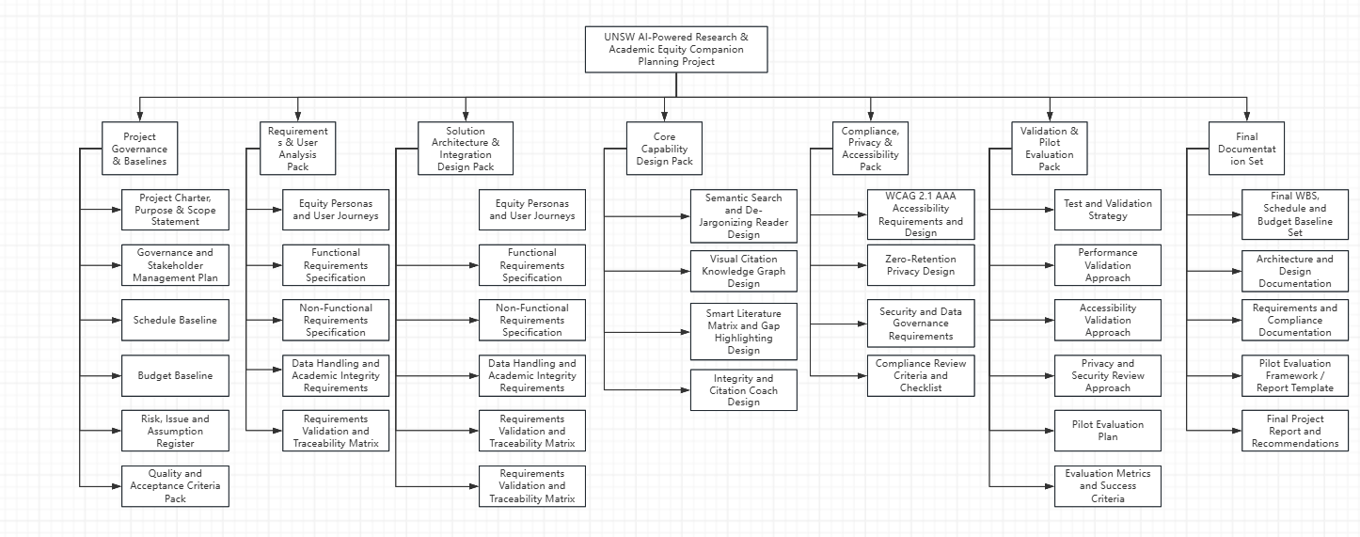

Stakeholder Management

Stakeholder Identification
Stakeholder identification was used to determine who could influence the project, who would be affected by it, and who might expect involvement in project decisions. This step matters because the AI-Powered Research & Academic Equity Companion involves different groups with different priorities, authority levels, and expectations. Identifying them early gives the team a clearer picture of who needs to be consulted, who needs regular updates, and who may shape major project decisions later on.
To identify stakeholders, the team used brainstorming, which is listed in PMBOK section 13.1.2.2 (6th ed.) as a data-gathering technique. During group discussion, we listed everyone who could be involved in or affected by the project across initiation, planning, design, approval, delivery, and future use. This helped us capture both internal and external stakeholders rather than focusing only on the people directly working on the project.
After this first pass, we organised the results using a stakeholder register, based on PMBOK section 13.1.3.1 (6th ed.). The detailed table is shown below.
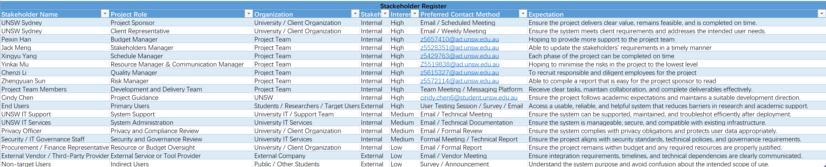
The register gives the team a practical way to record and compare stakeholders. It includes details such as role, organisation, classification, level of influence, level of interest, preferred communication method, and key expectations. Recording this information in one place makes later analysis much easier because the team can see which stakeholders need close management and which ones mainly need updates or consultation.
For this project, the main stakeholders include the project sponsor, client representative, project manager, project team members, end users, project supervisor or tutor, technical support staff, system administrators, university IT services, external vendors, and compliance-related representatives such as privacy, security, or procurement staff. These groups do not look at success in the same way. The sponsor is likely to focus on feasibility, value, and timely delivery, while end users care more about usability, accessibility, reliability, and whether the system actually helps with research learning. Because of that, stakeholder identification is not just a list-making exercise. It also helps the team understand what each group expects from the project.

Stakeholder Engagement Plan
To plan how stakeholders should be engaged once the project begins, the team used the power-interest grid from PMBOK section 13.1.2.4 (6th ed.). Based on the stakeholder register, stakeholders were grouped into four categories: manage closely, keep informed, keep satisfied, and monitor. This method helps the team decide where regular effort should go and where lighter communication is enough.
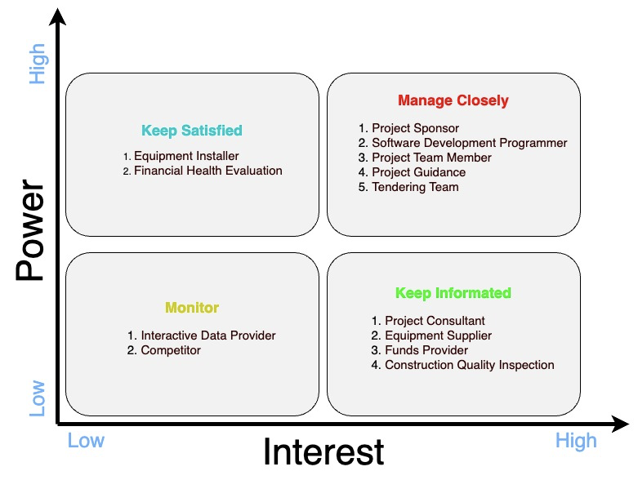
The manage closely group contains stakeholders with both high power and high interest. In this project, that includes the sponsor, client representative, project manager, project supervisor, and project team members. These people shape project direction, approve key decisions, clarify requirements, assign resources, and review major outputs. Because their involvement directly affects progress, they need regular meetings, milestone reviews, and frequent communication so that decisions stay aligned with project priorities.
The keep informed group includes stakeholders with high interest but less formal decision-making power. In this project, that mainly includes end users, operational support staff, and system administrators who may use or support the system later. Even though they may not approve major decisions, their feedback is still valuable because they can point out issues with usability, accessibility, workflow fit, and day-to-day practicality. They should therefore receive regular updates and be invited to reviews, demonstrations, or feedback sessions where their input can be used.
The keep satisfied group includes stakeholders with relatively high power but lower day-to-day involvement. This may include IT governance staff, privacy or security officers, procurement or finance representatives, and senior administrative decision-makers. These stakeholders are usually more concerned with compliance, policy alignment, budget control, and technical approval than with daily project tasks. For that reason, the team should give them concise updates and relevant documents at the right points, especially when approval or review is needed.
The monitor group contains stakeholders with both low power and low interest. Their direct influence is limited, so they do not need intensive communication unless project conditions change. In this project, that may include non-target users, external observers, or third parties with only occasional involvement. They still need to be tracked, but only at a light level unless their role becomes more important later.
Using the power-interest grid makes it easier to decide who needs close collaboration and who only needs periodic communication. That helps the team use time more effectively, reduce misunderstandings, and maintain better stakeholder relationships throughout the project.

Stakeholder Engagement Management
To build on the power-interest analysis, the team also used the stakeholder engagement assessment matrix from PMBOK section 13.2.2.5 (6th ed.). This matrix compares each stakeholder's current level of engagement with the level the project needs. The usual categories are unaware, resistant, neutral, supportive, and leading. By comparing current and desired states, the team can see where more communication or involvement is needed.
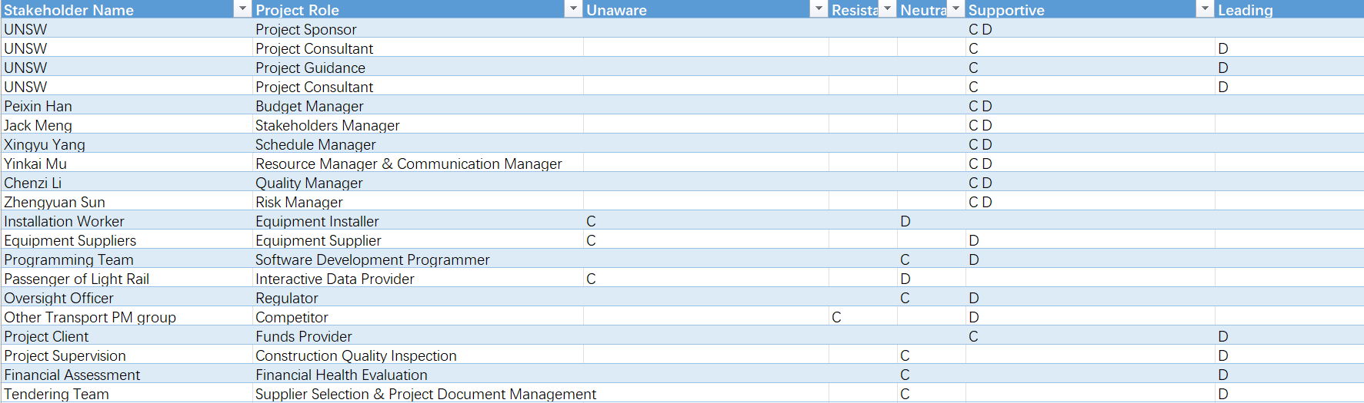
For some stakeholders, such as the sponsor, client representative, project supervisor, and project team members, the current level of engagement is already close to the desired level. These stakeholders are generally supportive or even leading because they are already involved in planning and decision-making. The team's main job here is to keep communication steady, confirm expectations, and continue involving them in reviews and key decisions so that support remains strong across the project.
Other stakeholders, including end users, technical support staff, and system administrators, may begin in a neutral position and need to be moved toward supportive. At the start, they may know the project exists but may not yet understand its practical value. The best way to improve engagement is to involve them through prototypes, demonstrations, feedback sessions, and testing activities. This gives them a clearer view of the project's benefits and also gives the team more grounded feedback.
For stakeholders such as privacy officers, IT governance staff, procurement representatives, or external vendors, the gap between current and desired engagement may be larger. Some may begin as unaware or remain neutral until approval, integration, or resource decisions become necessary. These stakeholders need earlier and more targeted communication. The team should explain the project purpose, technical direction, likely dependencies, and any compliance implications before critical milestones arrive. During approval, integration, or deployment-related stages, communication may need to become more frequent.
Stakeholder engagement management is therefore an ongoing process rather than a one-off activity. As priorities, risks, and stakeholder concerns change, the engagement approach should also be reviewed and adjusted so that support can be maintained and issues can be addressed early.

Stakeholder Engagement Monitoring
To support day-to-day communication, the team prepared a Stakeholder Contact Method and Communication Frequency table. This table makes it easier to match each stakeholder group with a suitable communication channel and an appropriate level of contact across the project lifecycle.
Monitoring stakeholder engagement matters because stakeholder expectations and influence can change as the project moves through planning, review, and final delivery. Someone who begins with limited interest may become more involved once they see progress, while another stakeholder may become concerned if there are delays, risks, or scope changes. For that reason, stakeholder engagement should be reviewed regularly, especially at milestones, sprint reviews, risk reviews, and after major feedback sessions.
Different stakeholder groups also need different communication methods. The project manager and team members may rely on meetings, shared task boards, and messaging tools for routine coordination. The sponsor and client representative may prefer milestone reports, presentations, and decision meetings. End users may be involved through demonstrations, prototype walkthroughs, surveys, or testing sessions. Technical and compliance stakeholders may need formal documents, short technical summaries, and scheduled consultations. Defining both method and frequency clearly helps the team stay consistent and avoid communication gaps.
Overall, stakeholder engagement monitoring gives the team a way to check whether stakeholder relationships are being managed effectively. It supports clearer communication, faster response to concerns, and better alignment between project work and stakeholder expectations. In that way, it also helps reduce project risk and improves the chance of successful delivery.

- Schedule Management
  - Discussion
Effective progress management is the key foundation for ensuring that the research and academic equity planning project based on artificial intelligence at the University of New South Wales can be completed within 12 months and within a budget of 350,000 US dollars. According to the knowledge area of progress management in the PMBOK, our project management team adopted a structured six-step process: planning progress management, defining activities, arranging activity sequence, estimating activity duration, formulating the progress plan, and controlling the progress plan.
Activity Definition
By systematically decomposing the seven primary work packages identified in the WBS, we obtained an activity list: project governance & baselines (1.1), requirements & user analysis pack (1.2), Solution architecture & integration design pack (1.3), core capability design pack (1.4), compliance, privacy & accessibility pack (1.5), validation & pilot evaluation pack (1.6), and final documentation set (1.7). Each work package will be further decomposed into specific, scheduleable secondary deliverables, ultimately resulting in 34 activities. For instance, 1.1 is broken down into six baseline documents and governance documents, including the project charter, purpose & scope statement (1.1.1), governance and stakeholder management plan (1.1.2), schedule baseline (1.1.3), budget baseline (1.1.4), risk, issue and assumption register (1.1.5), and quality and acceptance criteria pack (1.1.6). Similarly, 1.4 is decomposed into four core design deliverables: semantic search and de-Jargonizing reader design (1.4.1), visual citation knowledge graph design (1.4.2), smart literature matrix and gap highlighting design (1.4.3), and integrity and citation coach design (1.4.4). This bottom-up decomposition method ensures comprehensive coverage of the scope, with each deliverable being fully traceable to its superior work breakdown structure node, and there is no omission or duplicate calculation of work volume.
Duration Estimation
In order to obtain reliable and convincing project schedule estimation results, our team adopted three complementary estimation methods and coordinated the respective results according to the PMBOK. This was achieved through structured team discussions. At the macro level, we employed similar estimation methods, referring to the public schedules of similar university educational technology planning and requirements analysis projects, to establish stage-level schedule benchmarks. This estimation method is particularly important for estimating the requirements & use analysis pack (1.2) as well as the validation & pilot evaluation pack (1.6), as these two packages require industry-standard requirements acquisition and verification cycles to provide useful reference points. At the secondary deliverable level, we adopted a bottom-up estimation method: team members with relevant domain expertise independently estimated the workload and duration of each activity. We also paid special attention to those deliverables involving significant inter-team dependencies or requiring external review cycles, such as functional requirements specification (1.2.2 and 1.3.2), non-functional requirements specification (1.2.3 and 1.3.3), WCAG 2.1 AAA accessibility requirements and design (1.5.1), and requirements validation and traceability matrix (1.2.5 and 1.3.5). And all these deliverables require repeated solicitation of stakeholder opinions to establish benchmarks. Additionally, for activities with extremely high uncertainty, we used PERT to predict the required time buffer, especially the privacy and security review approach (1.6.4), pilot evaluation plan (1.6.5), and evaluation metrics and success criteria (1.6.6). In these activities, due to the uncertainty of the availability of external reviewers and pilot participants, there will be uncertain risks to our schedule arrangement. For these deliverables, we collected the optimistic, most likely, and pessimistic durations and calculated the average using the beta distribution formula (O + 4M + P) / 6. During team review meetings, we cross-compared the results of these three methods to determine the ultimately unanimously accepted activity duration, which includes the embedded risk response buffer described in Section 4.2.
Activity Sequencing and Critical Path
We classify the dependencies between activities based on the "completion-start" relationship, which is consistent with the sequence planning and logic of the project: most downstream deliverables can only truly start after the upstream inputs are completed and accepted. Only when it is feasible and does not bring quality risks, will we choose to use the "start-start" (SS) relationship. What is particularly notable is that work package 1.3 and work package 1.2 will be planned to be carried out simultaneously, coordinating the core requirements output and the architecture framework to initiate the development design. Similarly, work package 1.5 will be initiated after the first half of work package 1.4 is completed to meet the development requirements of Smart Literature Matrix and Gap Highlighting Design (1.4.3), WCAG 2.1 AAA Accessibility Requirements and Design (1.5.1), and Zero-Retention Privacy Design (1.5.2). Moreover, the formulation of Compliance Review Criteria and Checklist (1.5.4) will be carried out after the completion of Integrity and Citation Coach Design (1.4.4) and Security and Data Governance Requirements (1.5.3), because compliance design can be jointly verified after the two processes are merged. Based on the complete list of activities, we use the Priority Diagram Method (PDM) to construct a network diagram and calculate the earliest start time (ES), earliest completion time (EF), latest start time (LS), latest completion time (LF), and total float time for each activity. The critical path runs through the core planning to the verification process of the project: 1.1 (Project Governance & Baselines) → 1.2 (Requirements & User Analysis Pack) → 1.3 (Solution Architecture & Integration Design Pack) → 1.4 (Core Capability Design Pack) → 1.6 (Validation & Pilot Evaluation Pack) → 1.7 (Final Documentation Set). All activities on this path have no float time; any delay will directly extend the project completion date. Non-critical activities - especially individual deliverables in Section 1.5, such as WCAG 2.1 AAA Accessibility Requirements and Design (1.5.1), and independent documents in Section 1.7, such as Architecture and Design Documentation (1.7.2) - have approximately two to four weeks of float time, providing built-in flexibility for risk management while not affecting the final deadline.

The Gantt chart is the main tool for visualizing and tracking progress. It presents all secondary activities and their planned start and end dates, total duration (including risk buffer), and interdependencies in chronological order. The Gantt chart constitutes the progress baseline and will be reviewed at the bi-weekly project status meetings. Any progress deviations discovered during execution will first be resolved through internal resource reallocation, and any escalation issues will be communicated to the project sponsor. We will continue to use Earned Value Management (EVM) indicators to monitor project progress, focusing on schedule variance (SV = EV - PV) and schedule performance index (SPI = EV / PV), in order to provide objective and quantitative project time risk warnings during each reporting cycle of the project life cycle.
  - Activity List
The duration day for each activity including the risk response.
ID | Work Package | Duration | Start Date | End Date
1.1 | Project Governance & Baselines | 28 Days | 2 Mar 2026 | 29 Mar 2026
1.1.1 | Project Charter, Purpose & Scope Statement | 16 days | 2 Mar 2026 | 17 Mar 2026
1.1.2 | Governance and Stakeholder Management Plan | 9-10 days | 5 Mar 2026 | 14 Mar 2026
1.1.3 | Schedule Baseline | 6-8 days | 8 Mar 2026 | 15 Mar 2026
1.1.4 | Budget Baseline | 6-8 days | 8 Mar 2026 | 15 Mar 2026
1.1.5 | Risk, Issue and Assumption Register | 15 days | 10 Mar 2026 | 24 Mar 2026
1.1.6 | Quality and Acceptance Criteria Pack | 15 days | 15 Mar 2026 | 29 Mar 2026
1.2 | Requirements & User Analysis Pack | 39 days | 30 Mar 2026 | 7 May 2026
1.2.1 | Requirements & User Analysis Pack | 22 days | 30 Mar 2026 | 20 Apr 2026
1.2.2 | Functional Requirements Specification | 16-20 days | 1 Apr 2026 | 20 Apr 2026
1.2.3 | Non-Functional Requirements Specification | 16-20 days | 1 Apr 2026 | 20 Apr 2026
1.2.4 | Data Handling and Academic Integrity Requirements | 16-20 days | 1 Apr 2026 | 20 Apr 2026
1.2.5 | Requirements Validation and Traceability Matrix | 17 days | 21 Apr 2026 | 7 May 2026
1.3 | Solution Architecture & Integration Design Pack | 39 days | 30 Mar 2026 | 7 May 2026
1.3.1 | Equity Personas and User Journeys (Architecture View) | 22 days | 30 Mar 2026 | 20 Apr 2026
1.3.2 | Functional Requirements Specification (Architecture View) | 16-20 days | 1 Apr 2026 | 20 Apr 2026
1.3.3 | Non-Functional Requirements Specification (Architecture View) | 16-20 days | 1 Apr 2026 | 20 Apr 2026
1.3.4 | Data Handling and Academic Integrity Requirements (Architecture View) | 16-20 days | 1 Apr 2026 | 20 Apr 2026
1.3.5 | Requirements Validation and Traceability Matrix (Architecture View) | 17 days | 21 Apr 2026 | 7 May 2026
1.4 | Core Capability Design Pack | 177 days | 8 May 2026 | 31 Oct 2026
1.4.1 | Semantic Search and De-Jargonizing Reader Design | 97 days | 8 May 2026 | 12 Aug 2026
1.4.2 | Visual Citation Knowledge Graph Design | 97 days | 8 May 2026 | 12 Aug 2026
1.4.3 | Smart Literature Matrix and Gap Highlighting Design | 49 days | 13 Aug 2026 | 30 Sep 2026
1.4.4 | Integrity and Citation Coach Design | 31 days | 1 Oct 2026 | 31 Oct 2026
1.5 | Compliance, Privacy & Accessibility Pack | 110 days | 13 Aug 2026 | 30 Nov 2026
1.5.1 | WCAG 2.1 AAA Accessibility Requirements and Design | 45-49 days | 13 Aug 2026 | 30 Sep 2026
1.5.2 | Zero-Retention Privacy Design | 45-49 days | 13 Aug 2026 | 30 Sep 2026
1.5.3 | Security and Data Governance Requirements | 30-33 days | 1 Oct 2026 | 2 Nov 2026
1.5.4 | Compliance Review Criteria and Checklist | 23-28 days | 3 Nov 2026 | 30 Nov 2026
1.6 | Validation & Pilot Evaluation Pack | 62 days | 1 Dec 2026 | 31 Jan 2027
1.6.1 | Test and Validation Strategy | 33-36 days | 1 Dec 2026 | 5 Jan 2027
1.6.2 | Performance Validation Approach | 33-36 days | 1 Dec 2026 | 5 Jan 2027
1.6.3 | Accessibility Validation Approach | 33-36 days | 1 Dec 2026 | 5 Jan 2027
1.6.4 | Privacy and Security Review Approach | 33-36 days | 1 Dec 2026 | 5 Jan 2027
1.6.5 | Pilot Evaluation Plan | 51 days | 1 Dec 2026 | 20 Jan 2027
1.6.6 | Evaluation Metrics and Success Criteria | 11 days | 21 Jan 2027 | 31 Jan 2027
1.7 | Final Documentation Set | 20 days | 1 Feb 2027 | 20 Feb 2027
1.7.1 | Final WBS, Schedule and Budget Baseline Set | 7 days | 1 Feb 2027 | 7 Feb 2027
1.7.2 | Architecture and Design Documentation | 7-20 days | 1 Feb 2027 | 20 Feb 2027
1.7.3 | Requirements and Compliance Documentation | 7-20 days | 1 Feb 2027 | 20 Feb 2027
1.7.4 | Pilot Evaluation Framework / Report Template | 13 days | 8 Feb 2027 | 20 Feb 2027
1.7.5 | Final Project Report and Recommendations | 13 days | 8 Feb 2027 | 20 Feb 2027

  - Milestone Timeline
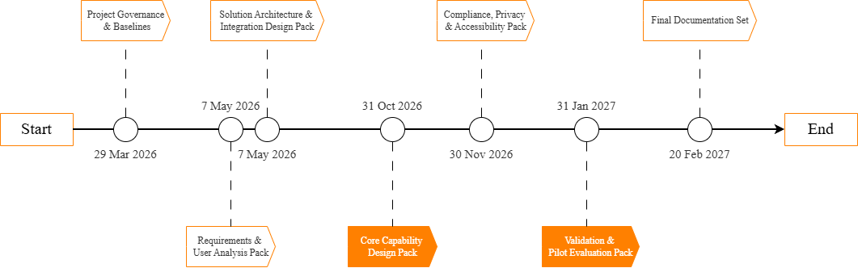

  - Network Diagram
The Network Diagram is focusing on the logical relationships between activities, and is particularly useful for analysing task dependencies, allocating program resources, identifying critical paths, and assessing the impact of task delays on project schedules which can help with better risk identification and response.
In our Network Diagram, we show the early start, early finish, late start, late finish and duration days for each activity. We can see more clearly whether there can be parallelism between different activities and whether there is spare budgeted time for each activity to deal with risks.
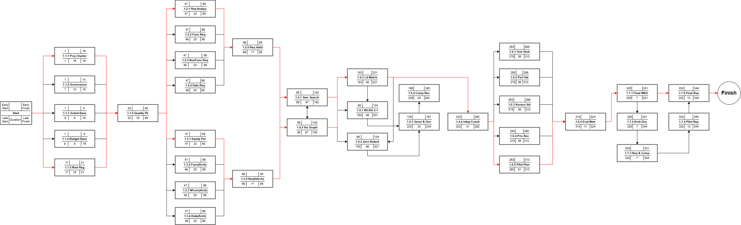

  - Gantt Chat
The Gantt chart visualizes the project schedule, enabling project managers to quickly understand the progress status of the project and the timing of each activity.
In our Gantt Chart, we show all the program activities with their duration days, start dates, and end dates in chronological order. The duration of a higher level activity is the sum of the duration days of its sub-level activities. For our schedule management, the Gantt Chat is useful to let us compare the project progress at the current point with the planned progress during the project, so that our team is always aware of whether the progress is behind or at risk.
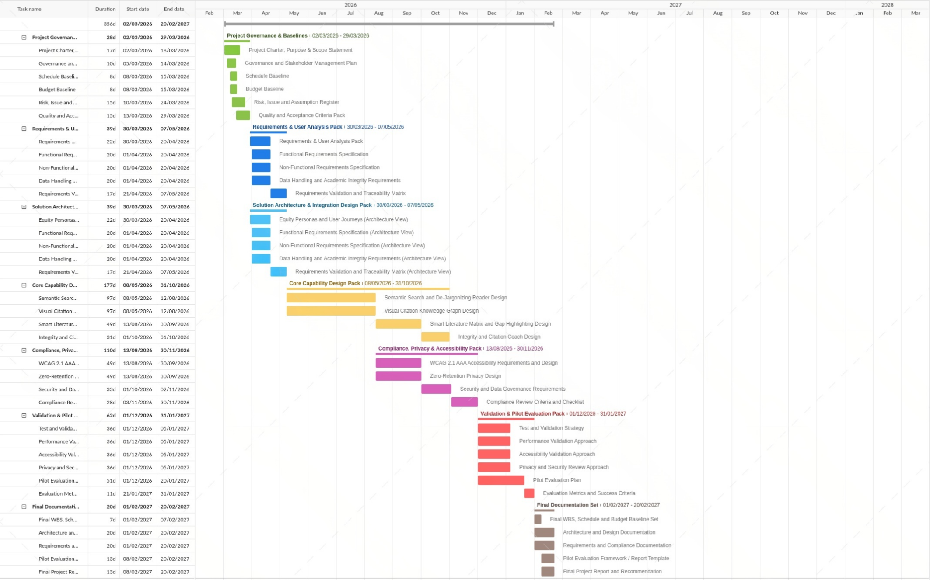

Budget Management
The budget for UNSW AI-Powered Research is 350000 AUD. This budget includes a 12-month plan from March 2026 to February 2027, based on project brief and PMP. The major costs are labour work for designing the system. Few money will be spent for some support tools. A contingency of 5 percent of total cost is also required.

Overview of Budget
The budget is based on the work packages in the WBS and checked against the total budget limit. Most of the cost is labour, because most of the project work includes requirements analysis, AI system design and UX design. Non-labour cost is relatively low since only a few design tools are needed, and their subscription fee is quiet low.
The budget is separated into 7 parts according to the packages in the current WBS to make sure it remains consistent with the scope and schedule. The largest one is Core Capability Design because this part requires professionals who can design systems, and it also takes the longest time. The other parts are relatively lower.
WBS package | Schedule window | Lead role | Main cost drivers | Estimated cost (AUD) | Notes
1.1 Project Governance & Baselines | 2-29 Mar 2026 (28 days) | Project Manager | Project planning, baseline drafting, governance reviews | 11900 | Estimate with PM rate x planned input days within the 28-day window
1.2 Requirements & User Analysis | 30 Mar-7 May 2026 (39 days) | Business Analyst / User Research Lead | Requirements workshops, user analysis, traceability work | 17100 | Estimate with BA / research rate x planned input days
1.3 Solution Architecture & Integration Design | 30 Mar-7 May 2026 (39 days) | Solution Architect / Technical Lead | Architecture planning, integration approach, design reviews | 20900 | Estimate with architect / technical lead rate x planned input days
1.4 Core Capability Design | 8 May-31 Oct 2026 (177 days) | AI Design Lead + UX Lead | Concept design for core functions, workshop iterations, design artefacts | 90000 | Largest labour package; estimate with AI + UX design input days
1.5 Compliance, Privacy & Accessibility | 13 Aug-30 Nov 2026 (110 days) | UX / Accessibility Lead | Accessibility planning, privacy design, governance criteria | 34000 | Add accessibility / privacy review tools only if they are counted
1.6 Validation & Pilot Evaluation | 1 Dec 2026-31 Jan 2027 (62 days) | QA / Pilot Evaluation Lead | Validation planning, pilot preparation, training and feedback activities | 23200 | Add pilot support items only if they are counted
1.7 Final Documentation Set | 1-20 Feb 2027 (20 days) | Project Manager | Final report set, baseline pack, close-out documentation | 5950 | Estimate with PM input days

Integrated Project Budget
The integrated project budget includes two main parts: labor cost and direct supporting cost. Labor estimates are based on the current salary for each role according to some job websites such as SEEK.com and the total working time according to the schedule. Direct supporting cost is included when needed.
Labour subtotal | Tool cost subtotal | Contingency reserve | Total current estimate
203050 AUD | 426 AUD | 10173 AUD | 213649 AUD

Time-Phased Budget

Phase / period | Main WBS focus | Expected cost profile | Estimated amount (AUD) | Reason for profile
Phase 1: Mar 2026 | 1.1 Governance & Baselines | Moderate | 11900 | Project start-up, governance setup, and baseline drafting
Phase 2: Apr-May 2026 | 1.2 Requirements + 1.3 Architecture | Moderate to high | 42000 | Requirements workshops, user analysis, and solution architecture planning
Phase 3: Jun-Oct 2026 | 1.3 Architecture + 1.4 Core Capability Design | High | 113200 | Longest design package with sustained concept design, workshops, and design artefacts
Phase 4: Nov 2026–Feb 2027 | 1.5 Compliance / Privacy / Accessibility + 1.6 Validation / Pilot Evaluation + 1.7 Final Documentation | Moderate to high | 35950 | Final compliance review, pilot readiness, validation activities, training support, and project close-out documentation

Cost Estimation Table
The role allocation below has been chosen to match the approved WBS, the schedule windows, and the current risk owners already named in the risk plan.
Cost Category | Role / Resource | Reference Rate | Estimated Input Days | Estimation Note | Source
Labour rate | Project Manager | 850 AUD/day | 21 | Used mainly for governance, coordination and close-out activities | SEEK salary guide / Talent.com Australia
Labour rate | Business Analyst / User Research Lead | 900 AUD/day | 19 | Used for workshops, requirements capture and traceability work | SEEK salary guide / Talent.com Australia
Labour rate | Solution Architect / Technical Lead | 1100 AUD/day | 19 | Used for architecture planning and integration design reviews | SEEK salary guide / Talent.com Australia
Labour rate | UX / Accessibility Lead | 700 AUD/day | 45 | Used for accessibility and UX design input across design packages | SEEK salary guide / Talent.com Australia
Labour rate | AI Design Lead / Functional Design Lead | 1300 AUD/day | 45 | Used for core capability concept design and functional design input | SEEK salary guide / Talent.com Australia
Labour rate | QA / Pilot Evaluation Lead | 800 AUD/day | 29 | Used for validation readiness and pilot evaluation activities | SEEK salary guide / Talent.com Australia
Tool cost | Figma or equivalent design/prototyping subscription | 22 AUD/month | N/A | Used for interface mock-ups, wireframes, and design artefacts. | Official Figma pricing page
Tool cost | Miro or equivalent workshop / mapping tool | 20 AUD/month | N/A | Used for workshop facilitation, mapping activities, and collaborative planning. | Official Miro pricing page

Contingency Reserve
A 5% contingency reserve is added to the cost as there might be some unexpected situations. The project may face a lot of problems such as budget pressure, scope creep, and security issues, and the contingency reserve can help with them. The contingency reserve is separated

Cost Estimates Basis
Cost estimates in this budget are mostly labour costs and are related to the responsible role of the work, total working time, and effort. The cost of tools is also included when there is a need to subscribe to some AI-assisted design tools such as Figma. A bottom-up estimate has been used to estimate the cost for each package to make sure the total cost remains under AUD 350,000.

PMBOK Referenced PM Methods
Planning Cost Management
Cost estimates for this project will be done before the budget baseline is confirmed. If there is any change during the project, it will be estimated in the same way. The budget should be checked when the project is in progress, as there might be some factors that change the total cost.
Estimate Costs
A bottom-up method is used because the WBS and activities are confirmed. Labour estimates are based on the roles, current pay, and estimated working duration. The direct costs are relatively low because only some software tools are used in this project. The result is checked to make sure it is reasonable for a 12-month university project.
Determine Budget
The total budget is the combination of labour costs, direct supporting costs, and the contingency reserve. Once the amount is confirmed, the budget baseline is confirmed. The baseline also remains consistent with the schedule baseline, risk plan, and communication plan.
Control Budget
Budget performance should be checked once a month. If there is a risk of overspending, the project sponsor should be informed as soon as possible. Before making changes to the baseline, a few steps should be taken, such as adjusting the sequence of the work or postponing some less important work.
- Risk Management
  - Overview of Risk Management
Risk management involves taking measures to address potential issues that may arise during the identification, analysis, response, and monitoring stages of the successful delivery of UNSW's artificial intelligence-driven research and academic projects. Since this project is supported by academia, involves privacy data, and is related to the university system, proactive risk management becomes extremely important to safeguard the project's goals, progress, budget, etc. This project will adopt the structured risk management approach based on the PMBOK principles, starting to identify risks at the beginning and conducting regular checks throughout the project's completion process. The entire team will list the likelihood of risk occurrence, such as in terms of schedule, cost, quality, compliance, and the degree of trust from stakeholders, conduct risk assessment for each part, and based on this assessment, specify appropriate response strategies for the subsequent project progress.
Risk assessment and intervention will be integrated into the ongoing progress of the project. The project manager will be responsible for the risk register and will work with the project team and key stakeholders to set regular risk review times. For some very serious risks, in some necessary circumstances, they need to be reported to the project supervisor and relevant university supporters. This ensures that risks can be reported and resolved promptly, and also guarantees that the project can continue to operate within the prescribed framework. Since the original intention of this system is to support the interests and academic development of students, many risks have already exceeded the technical scope and entered the social level of ethics, legal reputation, etc. Therefore, the risk management of this project not only needs to address actual risks, but also needs to address risks in terms of interests related to students, society, and the university.
  - Risk Identification
In order to complete the risk identification of the entire system, the entire risk module is divided into six categories: technical issues, privacy and compliance issues, academic integrity and ethics issues, fairness and accessibility issues, issues related to the adoption by stakeholders and users, and some issues related to project management itself. The technical aspect concerns platform development and performance, and these risks include possible errors in semantic search, slow generation of knowledge frameworks, uneven quality levels of literature matrices, integration issues with various interfaces such as APIs, Moodle, and the library of the University of New South Wales, as well as issues with system response speed during peak paper submission periods.
The data privacy and compliance risk area also needs to be strengthened in inspection, as the platform may handle students' drafts, uploaded papers, and sensitive academic works, etc. Problems such as poor data processing, insecure storage, or sometimes the saving of content causing damage to trust and exposing the university to legal issues can all harm trust and put the university at risk. Academic integrity and ethics issues arise from the platform providing some guidance on papers, making explanations regarding citations, etc. Some students may misuse the intended functions of this project for themselves, blur the boundaries between the idealized role of the project and academic misconduct, or sometimes the answers given by artificial intelligence may introduce misleading answers that are interpreted by students. Issues related to accessibility and fairness are also very important, as this project is intended to support some student groups that are not typically outstanding or exceptional. If the platform does not meet the WCAG 2.1 AAA standard or its interface cannot be used by some disabled, non-native English speakers, or those with different ideological backgrounds, then the project may not achieve its expected effect.
Issues related to stakeholders and user adoption include arrogance towards artificial intelligence tools, and the insufficient understanding by students, mentors, library teams, and information technology service personnel of the benefits that the project can bring. Project management issues include underestimating the complexity of development, not having well-defined requirements, having a broad scope, insufficient resources, and pressure in the approval and budgeting aspects. Due to the limited scope, time, and budget of this project, it may have a significant impact on the completion of the project.

  - Risk Assessment
The project team will adopt an assessment method based on probability and impact. The likelihood and severity of risk occurrence will be classified into three levels: low, medium, and high. The risks with the highest likelihood and the greatest impact will be categorized as priority risks and need to be dealt with immediately and monitored continuously. Probability refers to the likelihood of the event occurring throughout the entire project process. Impact refers to the severity of the consequences on the project schedule, cost management, project scope, various stakeholders, etc. after the occurrence of the event.
For this project, the most prioritized risks are expected to include data privacy leakage, issues with artificial intelligence output, failure of the university system integration, non-compliance, and disapproval from stakeholders. These risks are given priority because they may directly undermine the final strategic goals. Risk review will be conducted at regular intervals, including determining requirements, initial deliverables, overall testing, experimental phases, and internal testing reviews. Once new issues arise, they will be added to the risk register; while existing risks will be updated according to changes in project conditions.
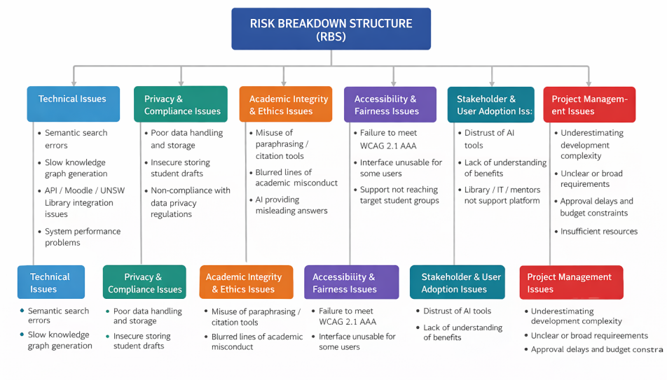

Risk register
Risk ID | Risk Description | Category | Probability | Impact | Priority | Response Strategy | Risk Owner
R1 | Student drafts or uploaded files are exposed due to weak data handling or storage controls | Data Privacy / Compliance | Medium | High | High | Enforce zero-retention architecture, encrypt data in transit, conduct security testing, and restrict access permissions | Technical Lead
R2 | AI explanations or paraphrasing suggestions are inaccurate or misleading, reducing academic quality | Technical / Ethical | High | High | High | Use human-centred testing, validate outputs with academic advisors, and position the tool as support rather than an authoritative content generator | AI Lead
R3 | Students misuse the platform in ways that raise academic integrity concerns | Ethical / Stakeholder | Medium | High | High | Add usage guidelines, warning messages, citation coaching, and alignment with UNSW academic integrity policy | Project Manager
R4 | Platform fails to meet WCAG 2.1 AAA accessibility requirements | Accessibility / Quality | Medium | High | High | Conduct accessibility testing early, involve representative users, and include accessibility criteria in acceptance testing | UX Lead
R5 | Integration with UNSW Library APIs, Moodle, Zotero, or EndNote is more complex than expected | Technical / Schedule | High | Medium | High | Begin integration planning early, build prototypes, and maintain contingency time in the schedule | Technical Lead
R6 | System performance is insufficient, especially for knowledge graph generation on 50+ papers or during peak usage periods | Technical / Performance | Medium | High | High | Conduct load testing, optimise architecture, and prioritise scalable cloud design | Technical Lead
R7 | Stakeholders such as students, supervisors, or university staff do not trust or adopt the platform | Stakeholder / Benefits | Medium | High | High | Run pilot trials, gather feedback, provide training and demonstrations, and communicate benefits clearly | Project Sponsor / PM
R8 | Project requirements expand beyond agreed scope, creating schedule and budget pressure | Project Management | High | Medium | High | Apply formal scope control, prioritise MVP features, and require sponsor approval for major changes | Project Manager
R9 | Budget of $350,000 is insufficient due to underestimated AI development or integration effort | Cost | Medium | Medium | Medium | Track actual costs regularly, maintain contingency reserve, and re-prioritise lower-value features if required | Project Manager
R10 | Delays in approvals, user feedback, or testing push delivery beyond the 12-month timeline | Schedule / Governance | Medium | Medium | Medium | Set milestone review dates early, assign decision owners, and escalate delays promptly | Project Manager
Conclusion. Effective risk management is of great significance for this project, as the platform involves multiple aspects such as schools, students, and society. By identifying and resolving risks as early as possible, the project team can enhance confidence in the delivery, protect the trust of stakeholders, and support the University of New South Wales in providing support to certain student groups.

Communications Management Plan
This Communications Management Plan is aimed at ensuring that critical updates is delivered to the targeted stakeholders promptly and via effective channels during the UNSW AI-Powered Research and Academic Equity Companion project. Since this project is aimed at the students underrepresented in the educational, technical, and governance sectors, the communication should be timely, precise, inclusive, and comprehensible. With effective communication, the chances of misunderstanding are minimized, decision-making is enhanced, stakeholders are more engaged, and the project team is able to respond in time to issues related to scope, privacy, accessibility, academic integrity, and readiness to deliver.
The PMBOK guide and the course materials have been used to develop the plan based on stakeholder-driven communication principles. It details the recipients of information, the purpose of information, what they are supposed to do with the information, the frequency at which information should be disseminated, the media to be used, and the escalation mechanism that should be used in case of an urgent communication or an absence of communication that may pose a risk to the project.

Overview
This is not only a software project, but also a change project within a university environment. Different groups of stakeholders hold varying perspectives: students require easy and facilitating guidance; academic advisors and supervisors require assurance that the platform can assist in research learning without compromising academic integrity; the project sponsor requires milestone reporting and decision-supportive summaries; UNSW governance or IT-related stakeholders require clear information about privacy, accessibility, security, and integration readiness. Thus, the project will involve the combination of formal and informal communication, and the complexity of the message depends on the needs of the stakeholders.

Plan Resource Management

Communication Requirement Analysis
The communication requirements were based on the project brief, the anticipated stakeholder groups, and the stakeholder management analysis carried out in Section 5. The analysis is conducted on the level of power, interest, level of expected engagement, and the need for information of each stakeholder group in operation. Concise decision-oriented updates are given to high-power stakeholders, and more frequent task-level communication and feedback loops are given to high-interest operational stakeholders.
Stakeholder / Group | Power | Interest | Main Information Needs | Preferred Communication Approach
Project Sponsor (UNSW Senior Leadership) | High | High | Milestones, major risks, budget/schedule variance, decisions required, alignment with UNSW Widening Participation Strategy 2035 | Monthly formal review meeting and concise written summary via email
Project Manager and Core Project Team | High | High | Task progress, dependencies, issues, action items, change requests, next-week priorities | Weekly team meeting via Microsoft Teams, shared task board, and group chat updates
Technical Lead, Developers, and QA Team | High | High | System design, integration tasks, testing outcomes, accessibility and privacy requirements, defect status | Weekly technical meeting via Teams, shared working documents, issue tracker, ad-hoc troubleshooting via group chat
Academic Advisors / Supervisors | Medium–High | High | Educational fit, user testing outcomes, concerns about research workflow support and integrity safeguards | Fortnightly review and milestone demo sessions via Teams or in person
Equity Students / Pilot Users | Medium | High | Pilot schedule, feature purpose, how to use the tool, privacy assurance, feedback channels, support availability | Plain-English emails, onboarding demo, FAQ document, feedback survey form
UNSW Library / IT Services | High | Medium–High | API and system integration status, privacy controls, compliance evidence, operational readiness | Gate review meetings and integration checklists, privacy briefs, and compliance evidence via email
Equity and Diversity Office | Medium–High | High | Equity feature progress, student feedback from pilot, alignment with 2035 Strategy targets, inclusive design compliance | Monthly progress report via email and quarterly review meetings
The communication plan is based on the reasoning of the power-interest and engagement tools of the stakeholder management plan. High-power, high-interest stakeholders like the sponsor, project manager, and technical leadership are closely managed with two-way communication. Low-power stakeholders with high impact on the project, such as student pilot users, are kept updated by using accessible messaging and active collection of feedback to ensure that adoption barriers and usability problems are identified at an early stage.

Communication Technology and Tools
The use of synchronous and asynchronous communication tools will be combined in the project in order to make the information available, traceable, and relevant to the audience. The choice of tools has been based on the urgency of information, availability, ease of use, the project environment, and sensitivity of information, as suggested by the PMBOK Guide.
• Microsoft Teams / Zoom: Main platform used to have regular meetings, demonstration sessions, sprint reviews, and discuss ad-hoc when urgent feedback is needed.
• Email (Outlook): Approval of formalities, milestones reporting, stakeholder summaries, and contractual documents.
• Trello or Kanban board: Task board in a visual format to monitor the status of work, its tasks, subsequent actions, and the progress of sprints.
• Shared Google Drive / OneDrive: Meeting minutes, decisions, technical specifications, testing evidence, and project documents.
• Survey forms (e.g., Google Forms): Structured gathering of student and stakeholder feedback in the pilot activities.
• Phone: Emergency channel of escalation of critical incidents that cannot be postponed until scheduled meetings.

Communication Methods
PMBOK Guide identifies interactive, push, and pull communication. All three are combined in this project to make sure that information is delivered to the right audience in the most effective way.
• Interactive communication: Where immediate feedback or a decision is needed, meetings, workshops, demos, and question-and-answer sessions are utilized.
• Push communication: Emails, reports, meeting minutes, and notices to the stakeholders where a formal record is required.
• Pull communication: Shared folders, dashboards, and project trackers that will be consulted by stakeholders when needed.
• Feedback communication: Surveys, pilot sessions, and interviews on understanding of platform, usability, accessibility, and trust.
These techniques are used in combination. As an example, a sponsor review can start with a push report, proceed with an interactive meeting, and conclude with updated documents on the shared repository. In particular, student communication must focus on being clear and reassuring: messages must articulate what is changing, why it is important, how it will impact them, how success will be evaluated, and where they can get support.

Project Information System Table
The table below summarises the key recurrent communication events of the project. It is in the format of course guidance: information, sender, recipient stakeholder, frequency, method, and owner.
Information / Event | Sender | Recipient / Stakeholder | Frequency | Method | Owner
Weekly progress update, open actions, blockers, next steps | Project Manager | Core project team | Weekly | Team meeting via Teams + task board | Project Manager
Architecture decisions, testing issues, integration status, accessibility and privacy concerns | Technical Lead | Developers, QA, PM | Weekly | Technical meeting via Teams + shared docs | Technical Lead
Major risks, escalations, mitigation status, required decisions | Risk Manager / PM | Sponsor, PM, Technical Lead | Weekly; immediate if critical | Email + urgent call/meeting | Project Manager
Milestone performance, strategic alignment, budget and schedule summary | Project Manager | Project Sponsor | Monthly | Formal report + review meeting | Project Manager
Educational fit, pilot findings, integrity concerns, feature priorities | PM / Comms Lead | Academic Advisors / Supervisors | Fortnightly | Review meeting + summary email | Project Manager
Pilot invitations, how-to guidance, support channels, privacy assurance, feedback request | Comms Lead | Equity Students / Pilot Users | At each pilot stage | Email, onboarding demo, FAQ, survey | Comms Lead
Compliance, security, zero-retention evidence, accessibility evidence, deployment readiness | PM / Technical Lead | UNSW Library / IT Services | At gateway reviews or monthly | Formal document pack + meeting | Project Manager
Equity feature progress, student feedback, 2035 Strategy alignment metrics | Project Manager | Equity and Diversity Office | Monthly | Email report + quarterly meeting | Project Manager
Change notice affecting schedule, scope, or stakeholder expectations | Project Manager | Relevant stakeholders | As required | Email + updated documents | Project Manager
Final handover package, user guide, lessons learned, closure summary | Project Manager | Sponsor, Library, IT Services | Project closeout | Presentation + final report | Project Manager

Manage Communications
The team will report to the project manager, who will ensure that communication continues. And the technical lead will maintain the communication going on in his own domain. Following critical meetings, the notes and actions will be kept and saved in a shared folder, so that the individuals can be aware of the tasks and not be confused. Communication will be presented and easy to understand. More detailed updates will be provided to the development team on the issue of system design and testing. Students will also get shorter and more direct messages with straightforward instructions and privacy/support guarantees. In case of any urgent matters (e.g., significant testing failure or privacy concerns) that are to be reported, they will not miss out on any new updates.

Monitor Communications
The team should consider whether the stakeholders are receiving the information that they require and, more to the point, whether they are comprehending it to a point that they are taking action. The timing is another question: do updates get shared in time, or are they shared too late when delays have already occurred?
With this project, other problems can be easily caused by communication problems. As an illustration, the students might not be sure how to use the system, or they might just disengage from the platform. Meanwhile, approvals may take longer, and some governance issues will emerge when nothing is clearly relayed. Certain usability issues might also remain undetected in case no one points them out at an earlier stage.

Collecting Feedback
The team will gather feedback in a number of ways so as to determine whether communication is effective. Post-pilot demos and testing will involve short surveys. Supervisors, advisors, and meetings with sponsors are also sources of feedback, albeit indirectly.
There are also internal discussions. They are not necessarily formal, but they can make the team think about whether the communication is understandable, whether the timing is appropriate, and whether the handovers are seamless. Simultaneously, the team must watch out for minor indicators, such as repetitive questions, slow approvals, unresponsive emails, or even those in which people appear to assume different things regarding the same matter.

Adjusting Communications
The team will adjust the protocols communication is conveyed. This can be in the form of modifying the degree of detail, intended audience, number of updates, communication media, or the time of escalation.
As an illustration, when the student users find instructions overly complex, they can be given less complex FAQs or step-by-step demonstrations. In case the sponsor decisions are delayed, the milestone summaries that are shorter and have more distinct decision points can be introduced. Unclear ownership can also be addressed to prevent technical rework, which can be achieved through a more frequent use of stand-up meetings and better tracking of actions.
By doing so, the problems in communication could be resolved at the initial stages and contribute to minimizing risks and ensuring the overall control of the project.

PMBOK Referenced PM Methods Used in Communications – Discussion
The given communication plan is based on the PMBOK concepts, especially communication and stakeholder management concepts.
Identification and analysis of stakeholders (PMBOK Part 1, Sec. 13) was a crucial factor in the development of this plan. The power-interest grid and stakeholder engagement assessment were the tools that were used to determine which stakeholders need close management, which ones should be informed, and which ones may need extra support to get more engaged. These findings were directly used to inform the Communication Requirement Analysis in Section 7.2.1.
Plan Communications Management process (PMBOK Part 1, Sec. 10.1) was also used to lead the way in which the communication activities are organized. This incorporates the aspect of what is to be shared, the delivery mode, when, and why it is to be shared. Along with the interval of meetings, the plan must specify the purpose of the individual communication, the response to be expected of the stakeholder, and the threats that may emerge in case the information is not delivered on time or is misinterpreted. This is especially relevant in this project because the quality of communication may influence the adoption of students, the confidence of sponsors, their readiness to comply, as well as privacy, access, and academic integrity risks.
The difference between interactive, push, and pull communication techniques (PMBOK Part 1, Sec. 10.1.2.4) was also taken into consideration in choosing the right communication methods. Discussions that need instant feedback are carried out by interactive methods, whereas those that entail the dissemination of standardized information are carried out through push methods. Pull methods enable the stakeholders to get the information as and when required.
Lastly, all these factors are combined in the Project Information System Table of Section 7.2.4, which connects information flows to their senders and recipients, frequency, communication mode, and owners. This enhances accountability and ease in reviewing communications and supports the project by minimizing ambiguity, and facilitates immediate escalation of issues in case of problems.

Quality management plan

Purpose of Quality Management
This Quality Management Plan aims to ensure the UNSW AI-Powered Research &amp; Academic Equity Companion project will deliver planning deliverables and proposed solution outputs that are complete, consistent, practical and fit for the project brief and UNSW strategic plan. This project is centred on planning and management rather than technical delivery, so quality management in this project refers to the quality of the project definition, design planning, validation planning, compliance planning, documentation, and project control mechanisms, as well as quality standards which would be used in the future implementation of the project.
The plan also helps with project control during the execution phase, by detailing how quality will be measured against the baseline, how variation will be detected, and how corrective action will be initiated if the project product does not achieve the required quality. This is consistent with the principle of project control that the plan should be used as a baseline for comparison against actual performance in order to detect deviations, assess response alternatives, and take corrective action.

Quality Objectives and Standards
This project's quality objectives are to deliver correct, complete, verifiable and implementable major products and to reflect the project's social and academic purpose. Specifically, the project must demonstrate the proposed platform design and other planning deliverables support equity student success, adhere to accessibility and privacy requirements, and remain within the planned time, cost and scope.
The major project quality standards are stipulated in the project brief. First, the project platform must comply with WCAG 2.1 AAA (including options such as text-to-speech for neurodiverse students). Second, the project must adopt a zero-retention privacy model for student thesis drafts, by analysing submitted drafts in volatile memory and excluding them in the training of public models. Third, quality requirements on performance must be met in the project planning documentation, such as generating a knowledge graph for 50+ papers within 15 seconds. Third, the platform must support integration with EndNote, Zotero and Moodle; and scalable use for peak periods, such as thesis deadlines.
Beyond the requirements for the product, the quality assurance also extends to the project documentation. Each part of the PMP must be consistent, consistent with WBS and scope baseline; use accurate and consistent terminology; and include reasonable assumptions. The final PMP must be professionally presented, well-integrated and usable as an execution planning package.

Quality Assurance Methods
In this project, the focus of quality assurance is on avoiding quality issues in the final product. The team will in-built review and verification activities to ensure quality assurance throughout the project development using the planned project phases. This is consistent with the lecture emphasis that quality is amongst items managed during the project execution phase, together with scope, schedule and cost.
The first quality assurance technique is checklists. Checklists will be written for key parts of the PMP, such as charter, scope, cost, schedule, stakeholder, risk, and quality, to ensure that appropriate content is included and in alignment with the project brief. The second method is peer review, in which others review the sections of their peers to check for unclear assumptions, inconsistent terms, loose language, and poor justification. The third method is milestone reviews for quality assurance, especially before the approval of requirements, before planning of design, before planning of validation, and for integration of the final report. These reviews provide controlled gates to allow work to proceed further.
The fourth method is section reviews. The quality control plan needs to line up with the non-functional requirements listed in the Project Brief, the validation plan must reflect the quality standards defined in the quality plan, and the schedule and budget must allocate enough time for reviews and other quality and compliance checks. This ensures that one part of the PMP does not make assertions that are inconsistent with any other part.

Quality Control Methods
In this project, quality control is the process of comparing actual or proposed solution and project performance and outputs with the conditions specified in this plan. As with the project control process in the lecture, quality control will compare actual performance to the planned performance and identify any deviations for corrective action if needed.
One quality control method will be performance tests. For the project, the tests will help determine whether proposed solution performance objectives are realistic and well defined. For instance, performance-based deliverables should demonstrate how the system will meet the timeliness requirement for knowledge graph generation and support high concurrency during peak processing times.
A second method is the use of schedule hold points. Hold points will occur before acceptance of deliverables such as before finalizing the list of requirements to be addressed, before acceptance of solution architecture deliverables, before development of a pilot evaluation plan, and before submission of the final report. No formal work will be allowed to continue until the appropriate deliverables have been reviewed and signed off on against the predetermined criteria. This will ensure that only good work is fed into the next level of detail.
The main quality control activities for this project are summarized in Table 7.1 below.
Table 7.1 Quality Control Summary
Quality Area | Control Method | Acceptance / Review Criteria | Responsible Role
Accessibility | Accessibility checklist and design review | Proposed solution aligns with WCAG 2.1 AAA requirements | Quality Lead + Project Team
Data Privacy | Compliance review and document inspection | Zero-retention privacy approach is clearly documented and consistent with the project brief | Quality Lead + Risk / Compliance Review
Performance | Performance testing review | Planning documents clearly address the requirement for knowledge graph generation for 50+ papers in under 15 seconds | Design / Validation Review Team
Integration | Requirements and design review | Integration with EndNote, Zotero, and Moodle is clearly addressed in planning outputs | Design Lead + Project Team
Documentation Quality | Peer review and integrated document inspection | Sections are complete, consistent, correctly formatted, and aligned with the PMP baseline | All Section Owners
Validation Planning | Milestone review and hold point approval | Validation approach, metrics, and pilot planning are complete, realistic, and aligned with project requirements | Quality Lead + Project Team

Quality Monitoring and Reporting
Quality monitoring in this project will follow the same general control logic used for project monitoring more broadly. A quality baseline will first be established through the project brief, the scope baseline, the WBS, the requirements specification, and the defined quality criteria in this plan. The team will then collect and review information on quality performance throughout the project, compare actual progress and outputs against the baseline, and report issues that require corrective action.
Data will be monitored to track the status of key deliverables, review issues, non-conformance to requirements, open corrective actions, and risks to accessibility, privacy, performance, integration or Good Documentation. This is in line with the lecture's discussion of monitoring of the project's outcome against the PMP baseline and corrective actions, if needed.
The quality monitoring and reporting approach for the project is summarized in Table 7.2 below.
Table 7.2 Quality Monitoring and Reporting Plan
Item to Monitor | Monitoring Method | Frequency | Reported To | Action if Issue Found
Deliverable completeness | Checklist review | At each major milestone | Project Team | Revise incomplete section before approval
Cross-section consistency | Integrated review and comparison with baseline | Weekly and before final integration | Project Team | Correct conflicting content and update affected sections
Accessibility compliance | Standards review against project brief | At design and validation checkpoints | Quality Lead | Revise relevant design or validation content
Privacy compliance | Compliance and requirements review | At compliance review point | Project Team | Escalate issue and revise privacy-related planning outputs
Performance requirements | Review against validation criteria | Before final validation approval | Project Team | Update validation method or technical assumptions
Final document quality | Final integrated inspection | Before submission | Whole Team | Correct formatting, numbering, and logic issues before submission

Quality Monitoring and Reporting
The control and monitoring activities outlined above need to be owned. As such, quality management responsibilities are divided in the following way.
Responsibility for quality is shared by all team members but will be allocated. The Charter & Quality lead is responsible for the preparation of this Quality Management Plan, overall coordination of cross-section reviews, monitoring the consistency across documents, and reviewing the final PMP integration. Section owners are responsible for technical accuracy, comprehensiveness and first-level quality for their sections. The rest of the project team is responsible for review and flagging inconsistencies, quality issues, and final milestone inspections and review.
This means, the schedule section owner ensures schedule products are internally consistent and compliant with the WBS. The budget owner is responsible for trackable and credible costs. The risk owner is responsible for ensuring key risks and response actions are complete and aligned with the rest of the PMP. The stakeholder and communication owners are responsible for stakeholder information and reporting needs. The quality lead then brings everything together in the project package.

Corrective Actions and Change Control
Where quality monitoring has indicated a departure from the agreed set of quality standards, corrective action is required as soon as possible. This accords with the lecture advice that bad news be reported early, since that affords more flexibility to the project manager in terms of corrective action, and also makes it less likely that an issue will become a serious problem.
Corrective measures may involve changing requirements, clarifying assumptions, improving documentation, revising acceptance criteria, repeating the peer review, improving compliance controls, or changing the proposed plan for validating that the new or modified requirements are fully met. For quality issues that affect scope, schedule, cost, performance or risk, the team will also need to decide whether the issues require a project change. The lecture notes that changes identified through project control can have an impact on schedule, budget, scope, quality, and performance, and that all possible impacts should be considered before changes are agreed.
Issues with scope, schedule, cost, performance, or compliance will be escalated and will be processed through the project change control process prior to updates to affected baseline documents.
If a major change is approved, changes will be made to the baseline documents so that quality monitoring is against the most recent version of the plan, not the initial plan. This prevents confusion, and keeps monitoring and control relevant throughout the life of the project.

PMBOK Referenced PM Methods Used in Quality Management – Discussion
This Quality Management Plan draws from PMBOK's ideas of quality management, but particularly related ideas of planning quality, managing quality, and controlling quality. In this project, quality planning means establishing those standards and criteria that will be adopted both for the solution and the project documents. Managing quality means incorporating practices in the project through review, inspections, cross-section coordination, and prevention. Controlling quality means comparing the expected baseline to the work delivered, and taking corrective action to resolve problems.
The plan is also consistent with principles of project control more generally discussed in the lecture. You must have a baseline at the beginning, you must gather and assess data while the project is in progress, you must measure performance against the baseline and you must take corrective action. The looped structure is applicable to quality management because quality cannot be maintained by merely setting expectations; quality must be measured and controlled.
Finally, the quality plan is interwoven throughout other areas of project management. Scope management provides scope for quality. Time management controls the timing of reviews and hold points. Cost management influences how much money can be spent on quality management. Risk management highlights potential quality risks, such as privacy and accessibility issues. Communications management affects reporting, escalation, and review operations. In this project, therefore, quality management should not be considered a separate chapter, but as an integrated management approach that drives the success of the PMP.

Appendix

Risk Register table

Category | Risk ID | Description | Associate Work Package | Owner | Severity | Likelihood | Risk Assessment | Overall Severity | Response Strategy | Response Action | Severity (After) | Likelihood (After) | Contingency Plan
Technical Risk | 1 | AI explanations or paraphrasing suggestions may be inaccurate or misleading, reducing academic quality and student trust. | AI Model Development | AI Lead | 4 | 4 | 16 | Extremely High Risk | Mitigation | Conduct model validation with academic staff, test outputs using sample papers, and add clear disclaimers that the tool provides support only. | 2 | 2 | Temporarily limit high-risk AI features, switch to a simplified support mode, and assign additional academic review before full release.
Data Privacy Risk | 2 | Student drafts or uploaded files may be exposed due to weak data handling, poor access control, or insecure storage. | Data Management and Security | Technical Lead | 5 | 3 | 15 | High Risk | Mitigation | Apply zero-retention architecture, encrypt data in transit and at rest, and restrict access through role-based permissions. | 2 | 1 | Suspend affected upload functions immediately, activate incident response procedures, notify relevant university stakeholders, and use contingency reserve for urgent remediation.
Academic Integrity / Ethical Risk | 3 | Students may misuse citation support or paraphrasing functions in ways that create academic misconduct concerns. | Integrity and Citation Support | Project Manager | 4 | 3 | 12 | High Risk | Mitigation | Add academic integrity guidance, warning notices, citation coaching, and usage controls aligned with UNSW policy. | 2 | 2 | Disable misuse-prone functions temporarily, revise user guidance, and require approval before reactivating the feature.
Accessibility and Equity Risk | 4 | The platform may fail to meet WCAG 2.1 AAA expectations or may not be usable for students with disability, neurodiverse learners, or non-native English speakers. | Accessibility and UX Design | UX Lead | 4 | 3 | 12 | High Risk | Mitigation | Conduct accessibility testing early, involve representative users, and include accessibility compliance in acceptance criteria. | 2 | 2 | Delay final rollout of affected modules and allocate additional design, testing, and accessibility review effort.
Technical / Integration Risk | 5 | Integration with Moodle, Zotero, EndNote, and UNSW Library systems may be more complex than expected, causing delays. | System Integration | Technical Lead | 4 | 4 | 16 | Extremely High Risk | Mitigation | Start integration planning early, create prototypes, and run interface testing before full system build. | 2 | 2 | Prioritise only core integrations for MVP release and defer lower-priority integrations to a later phase.
Performance Risk | 6 | System performance may be insufficient during peak demand, especially when processing multiple papers or generating knowledge graphs. | Performance Optimisation and Testing | Technical Lead | 4 | 3 | 12 | High Risk | Mitigation | Conduct load testing, optimise architecture, and use scalable cloud infrastructure for high-demand periods. | 2 | 2 | Add temporary cloud resources, reduce non-essential processing functions, and stagger high-load operations during early deployment.
Stakeholder / Adoption Risk | 7 | Students, supervisors, library teams, or university staff may not trust or adopt the platform. | Stakeholder Engagement and Pilot Deployment | Project Sponsor / PM | 4 | 3 | 12 | High Risk | Mitigation | Run pilot trials, collect feedback, demonstrate value through workshops, and communicate the platform's educational purpose clearly. | 2 | 2 | Refocus deployment on priority user groups, revise the communication plan, and extend the pilot period before full rollout.
Project Management Risk | 8 | Project requirements may expand beyond the agreed scope, increasing schedule pressure and budget usage. | Scope Management and Governance | Project Manager | 3 | 4 | 12 | High Risk | Mitigation | Apply formal change control, define MVP boundaries clearly, and require sponsor approval for major scope changes. | 2 | 2 | Defer lower-priority features to future phases and rebalance schedule and resources using approved contingency allowance.
Ethical / Fairness Risk | 9 | AI outputs may unintentionally disadvantage some student groups by producing biased explanations or uneven quality of support. | Ethical Review and Model Evaluation | AI Lead / UX Lead | 4 | 3 | 12 | High Risk | Mitigation | Test outputs across diverse student scenarios, review bias patterns regularly, and involve representative users in evaluation. | 2 | 2 | Pause affected model outputs, revise prompts or logic, and perform targeted fairness testing before relaunch.
Compliance / Governance Risk | 10 | Delays in university approvals, privacy review, or IT governance checks may postpone implementation. | Compliance Review and Approval Management | Project Manager | 3 | 3 | 9 | Moderate Risk | Mitigation | Engage governance stakeholders early, prepare documentation in advance, and track approval milestones closely. | 2 | 2 | Use schedule buffer for delayed approvals and resequence non-dependent activities while waiting for final clearance.
Training / Handover Risk | 11 | Insufficient training or support materials may reduce effective use of the platform during rollout. | User Training and Handover | Training Lead | 3 | 3 | 9 | Moderate Risk | Mitigation | Develop clear user guides, conduct training sessions, and provide a helpdesk channel during early rollout. | 2 | 2 | Extend the training period, provide extra workshops, and release simplified onboarding materials for key users.
Cybersecurity Risk | 12 | The system may be exposed to cyberattacks through insecure APIs, weak authentication, or third-party integration vulnerabilities. | Backend Security Management | Security Lead | 5 | 3 | 15 | High Risk | Transfer / Mitigation | Conduct penetration testing, strengthen authentication controls, and engage external security specialists for review. | 2 | 1 | Isolate affected systems, activate incident response, temporarily suspend external access points, and use emergency technical support to restore secure service.

Reference
• Project Management Institute (2017). A Guide to the Project Management Body of Knowledge (PMBOK Guide), 6th Edition.
• ASSIGNMENT 1 Part 2 Guidance for Project Management Plan Content, UNSW course file, GSOE9820 Term 1 2026.
• Week 4 Lecture Slides: Charter and Stakeholder Management, GSOE9820 Engineering Project Management, Term 1 2026, Dr. Imrana Kabir.
• Week 5 Lecture Slides: Risk and Communications Plan, GSOE9820 Engineering Project Management, Term 1 2026, Dr. Imrana Kabir.
• 26T1 Project Brief – UNSW AI-Powered Research & Academic Equity Companion.

